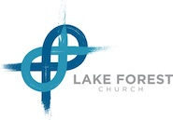
Parental Consent for Mission Trip

Legal Name of Minor(s): _________________________________________________________________

Date of Birth of Minor(s):________________________________________________________________

Name of Parent/Legal Guardian:___________________________________________________________

Destination of Trip:______________________ Date of Departure:_______ Date of Return:_______

I am the parent/Legal Guardian of the above Minor(s) and I grant permission to my child above to travel to the above destination during the above dates of the Mission Trip with Lake Forest Church. In addition, I authorize the below adult, who is going on the trip, to consent to any necessary routine or emergency medical treatment for my minor(s) during the Mission Trip.

Name of Adult Responsible for Minor(s) During Trip: __________________________________________

_________________________________ _______________
Signature of Parent/Legal Guardian Date

